Practical 5.1 – Advanced SQL 1

This is a checkpoint. Due Friday 31 Aug by 5.00 pm.

For the following exercises, please use the database shown below (this is the Microsoft “Pubs” database). Familiarise yourself with the database diagram, especially the relationships between entities, then write the indicated queries. Please read the instructions for each group of queries carefully.

You can find the scripts to create and populate the tables on the I: drive.

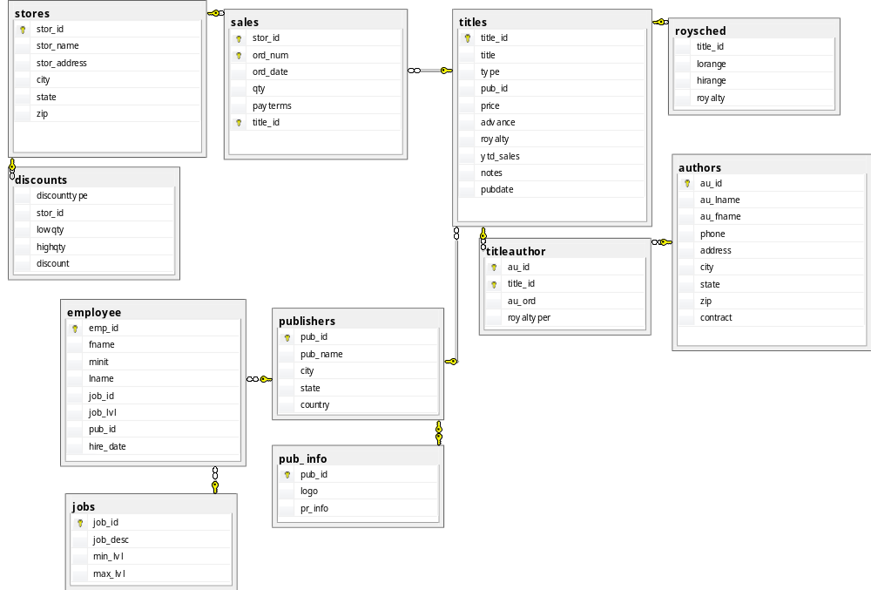

Queries 1-9: Although some of these queries can be written using only joins, the purpose of this exercise is to practice subqueries. Please be sure, therefore, that each solution contains at least one subquery.

- List the titles and prices of all books that have the cheapest price.

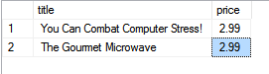

- List all titles that have sold more than 40 copies at a single store.

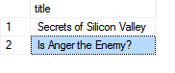

- List all authors who have not published any books.

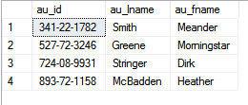

- List all the publishers who have published any business books.

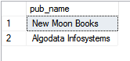

- List all authors who have published a “popular computing” book (these books have type = 'popular_comp' in the titles table).

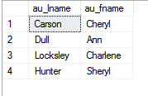

- List all the cities where both an author (or authors) and a publisher (or publishers) are located.

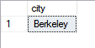

- List all cities where an author, but no publisher, is located.

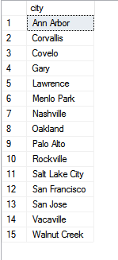

- List all titles that have sold no copies.



- List the title and total sales of each book whose total sales is less than the average total sales across all books.

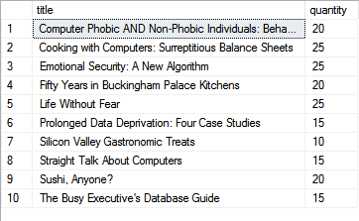

Queries 10-13: More aggregate practice. In addition to the required aggregation operations, use JOINS and/or subqueries, as you prefer.

- List the publishers, and the number of books each has published, who are not located in California.

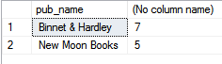

- For each book, list the number of stores where it has been sold.
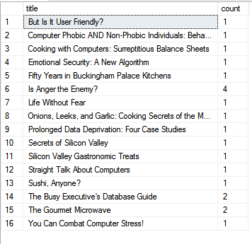

- For each book, list its title, the largest quantity of it sold at any one store, and the name of that store.
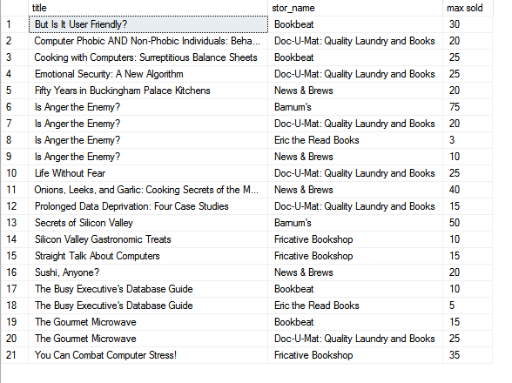

- Increase by two points the royalty rate for all books that have sold more than 30 copies total. (Just update the roysched table; ignore the denormalised value in titles.)

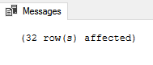

Query 14: Challenge Problem. Think carefully about what set you need to produce to answer this question, and what tables you need to join to produce that set.
- List all types of books published by more than one publisher.

